CAP Notes Home & School - Key to Abbreviations & Symbols

ME Concept Associations - A.S.K. Pictures & Processes
A  B  C  D | ____ ____ ____ |  | P# ___  ? √ 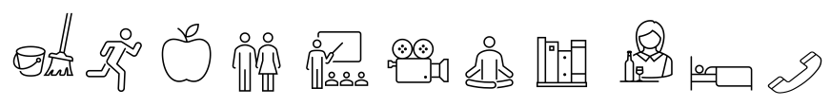
Home = am 5 6 7 8 9 10 11 12 pm 1 2 3 4 5 6 7 8 9 10 11 12
School = Time 1 5 10 15 20 25 30 35 40 45 50 55 60 90

 | Review | ? | Reviewed the last lesson. |  |  | Clean house, room, other
 | Demo |  | Demonstration by teacher/student/guest. |  | 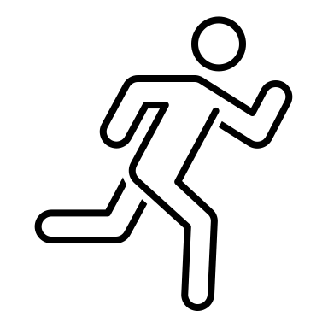 | Exercise your body
 | A / V |  | Watched / listened electronic device. |  |  | consume healthy Food
 | Read |  | Read textbook or other print material. |  |  | play with Friends
 | Write |  | Wrote – notebook, journal, or ‘other’. |  |  | Learning what you like
 | Make |  | Made ‘things’ alone, or in groups. |  |  | Media learning/entertain
 | Handout |  | Received paper to read, complete, edit or ‘other’. |  |  | Daily Meditation
 | Group Work |  | Worked together with a partner or group. |  | 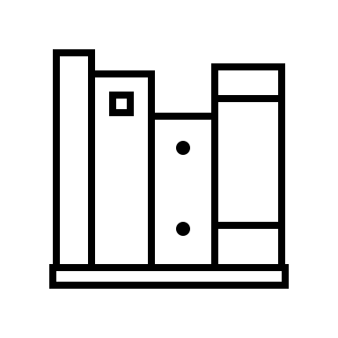 | Reading what you like
 | Computer |  | Used a computer to write, research, communicate. |  |  | Service help others
 | Practice |  | Practiced skills. |  | 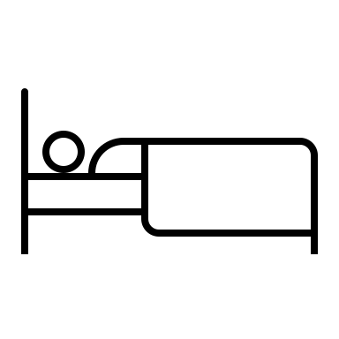 | Sleep well
 | Game |  | Played a game to reinforce A.S.K. |  |  | Talk friends, family, other
 | Evaluation | √ | Was tested or reviewed a test. |  | Enjoy  CAP Notes
 | CAP Notes |  | Summarize your learning.  Create Q & A’s

1.Answer It 2.Act It 3. Draw It 4.Spell It 5.Question It 6.Speak It 7.Move It
? Review Demo. a/v Read Write Make Worksheet Group Work Computer Practice Game √ Evaluation CAP Notes
M.E. = My Effort A = Attitudes / Feel S = Skills / Do K = Knowledge / Know = Audio/Hear = Visual/See = Kinesthetic/Touch

